

Muhammad Talha

P15-6087

Assignment#1

PART(A)

TABLES CREATION:

CREATE TABLE Customer

( CustNo VARCHAR(8) NOT NULL ,

CustName VARCHAR(30) NOT NULL ,

Address VARCHAR(30) NOT NULL ,

Internal CHAR(1) NOT NULL ,

Contact VARCHAR(30) NOT NULL ,

Phone CHAR(15) NOT NULL ,

City VARCHAR(20) NOT NULL ,

State CHAR(2) NOT NULL ,

Zip CHAR(10) NOT NULL ,

CONSTRAINT PK_CUSTOMER PRIMARY KEY (CustNo)

);

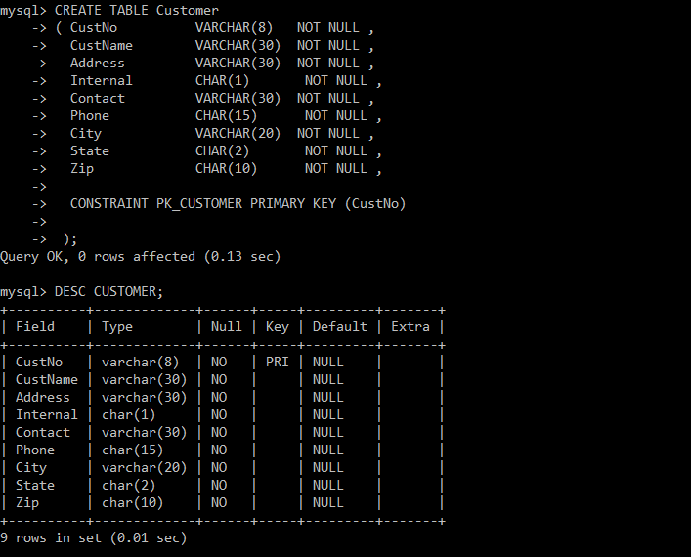

CREATE TABLE Employee

( EmpNo VARCHAR(8) NOT NULL,

EmpName VARCHAR(30) NOT NULL,

Department VARCHAR(30) NOT NULL,

Email VARCHAR(30) NOT NULL,

Phone CHAR(15) NOT NULL,

CONSTRAINT PK_EMPLOYEE PRIMARY KEY (EmpNo)

);

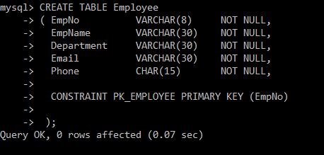

CREATE TABLE Facility

( FacNo VARCHAR(8) ,

FacName VARCHAR(30) ,

CONSTRAINT PK_FACILITY PRIMARY KEY (FacNo)

);

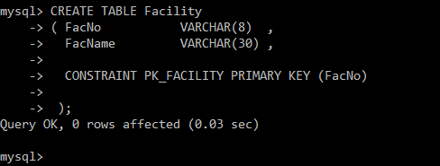

CREATE TABLE Location

( LocNo VARCHAR(8) NOT NULL,

FacNo VARCHAR(8) NOT NULL,

LocName VARCHAR(30) NOT NULL,

CONSTRAINT PK_LOCATION PRIMARY KEY (LocNo),

CONSTRAINT FK_LOCATION_FACILITY FOREIGN KEY (FacNo) REFERENCES Facility (FacNo)

);

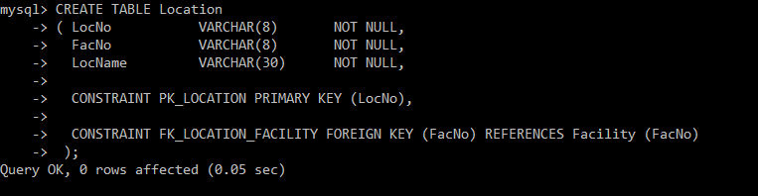

CREATE TABLE ResourceTbl

( ResNo VARCHAR(8) NOT NULL,

ResName VARCHAR(30) NOT NULL,

Rate DECIMAL(5,2) NOT NULL,

CONSTRAINT PK_RESOURCE_TBL PRIMARY KEY (ResNo),

CONSTRAINT RESOURCE_RATE_POS CHECK (Rate > 0)

);

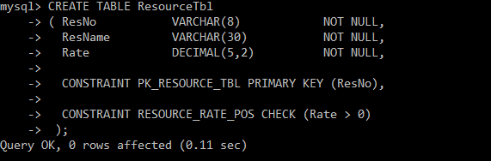

CREATE TABLE EventRequest

( EventNo VARCHAR(8) NOT NULL,

DateHeld DATE NOT NULL,

DateReq DATE NOT NULL,

FacNo VARCHAR(8) NOT NULL,

CustNo VARCHAR(8) NOT NULL,

DateAuth DATE ,

Status CHAR(10) NOT NULL,

EstCost DECIMAL(10,2) NOT NULL,

EstAudience DECIMAL(10) NOT NULL,

BudNo VARCHAR(8) ,

CONSTRAINT PK_EVENT_REQUEST PRIMARY KEY (EventNo),

CONSTRAINT FK_EVENT_REQUEST_CUSTOMER FOREIGN KEY (CustNo) REFERENCES Customer (CustNo),

CONSTRAINT FK_EVENT_REQUEST_FACILITY FOREIGN KEY (FacNo) REFERENCES Facility (FacNo),

CONSTRAINT EVENT_REQUEST_STATUS CHECK (Status IN ('Approved', 'Pending', 'Denied')),

CONSTRAINT EVENT_REQUEST_AUDIENCE_POS CHECK (EstAudience > 0)

);

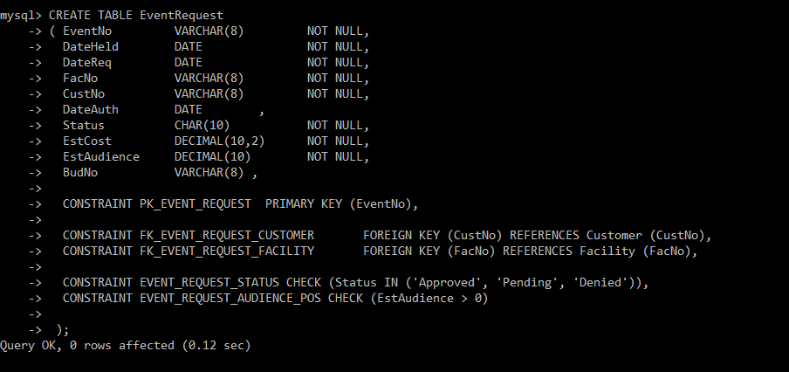

CREATE TABLE EventPlan

( PlanNo VARCHAR(8) NOT NULL,

EventNo VARCHAR(8) NOT NULL,

WorkDate DATE NOT NULL,

Notes VARCHAR(40) ,

Activity CHAR(10) NOT NULL,

EmpNo VARCHAR(8) ,

CONSTRAINT PK_EVENT_PLAN PRIMARY KEY (PlanNo),

CONSTRAINT FK_EVENT_PLAN_EVENT_REQUEST FOREIGN KEY (EventNo) REFERENCES EventRequest (EventNo),

CONSTRAINT FK_EVENT_PLAN_EMPLOYEE FOREIGN KEY (EmpNo) REFERENCES Employee (EmpNo)

);

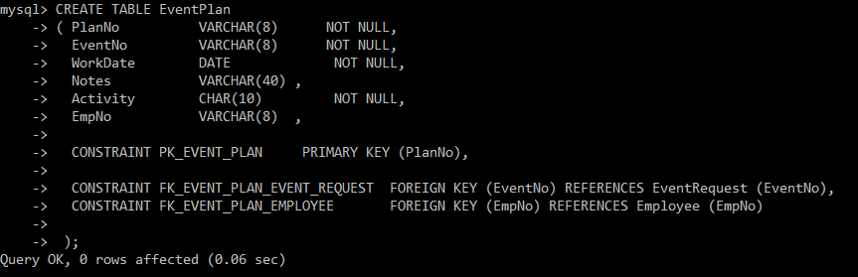

CREATE TABLE EventPlanLine

( PlanNo VARCHAR(8) NOT NULL,

LineNo DECIMAL(5) NOT NULL,

TimeStart DATE NOT NULL,

TimeEnd DATE NOT NULL,

NumberFld DECIMAL(5) NOT NULL,

LocNo VARCHAR(8) NOT NULL,

ResNo VARCHAR(8) NOT NULL,

CONSTRAINT PK_EVENT_PLAN_LINE PRIMARY KEY (PlanNo, LineNo),

CONSTRAINT FK_EPL_EVENT_PLAN FOREIGN KEY (PlanNo) REFERENCES EventPlan (PlanNo),

CONSTRAINT FK_EPL_LOCATION FOREIGN KEY (LocNo) REFERENCES Location (LocNo),

CONSTRAINT FK_EPL_RESOURCE_TBL FOREIGN KEY (ResNo) REFERENCES ResourceTbl (ResNo),

CONSTRAINT EPL_START_LT_END CHECK (TimeStart < TimeEnd)

);

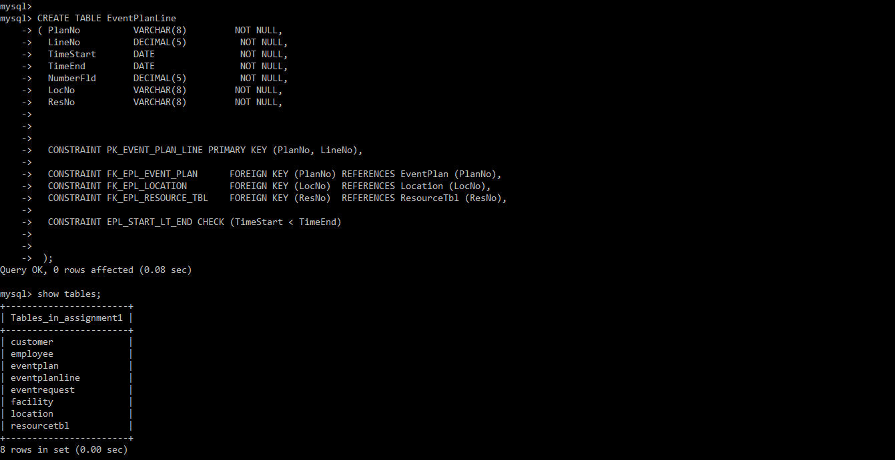

INSERTION:

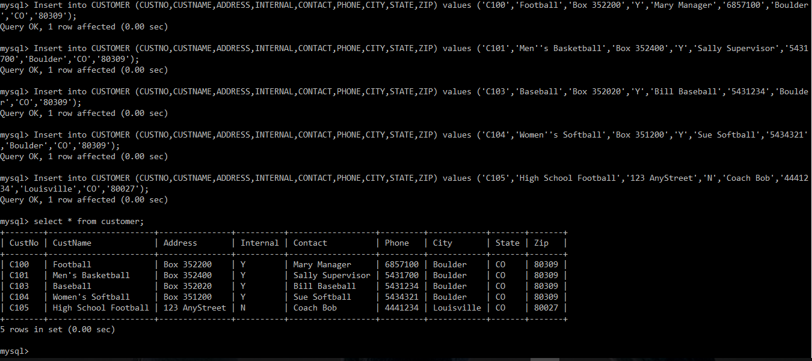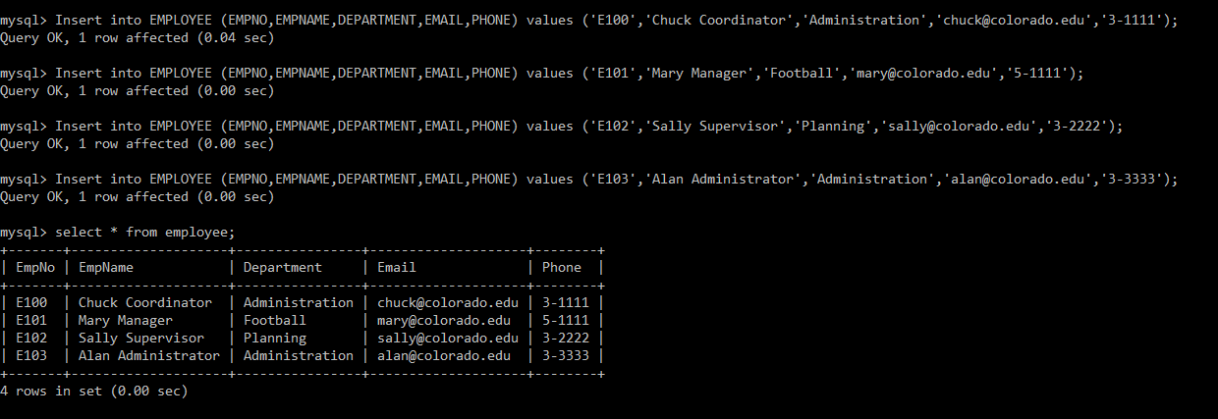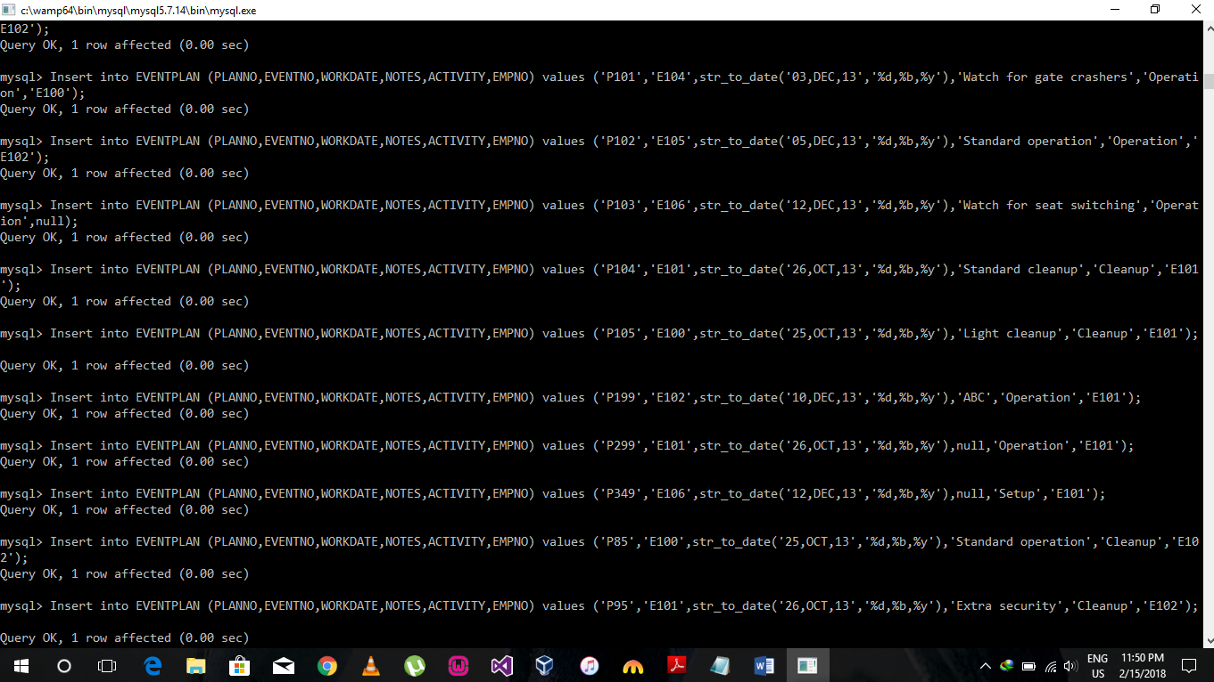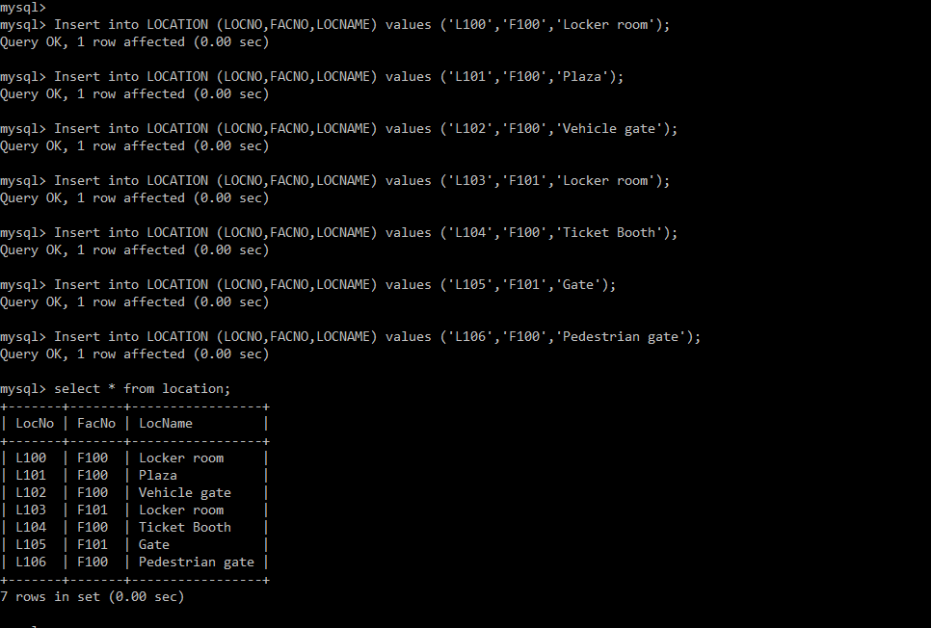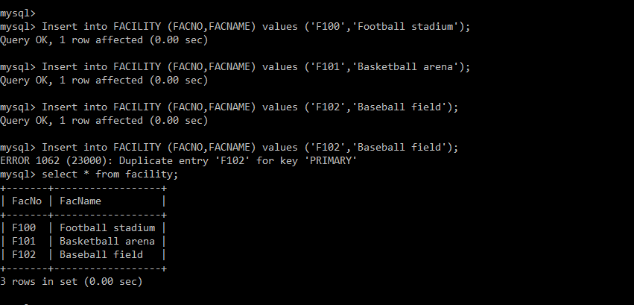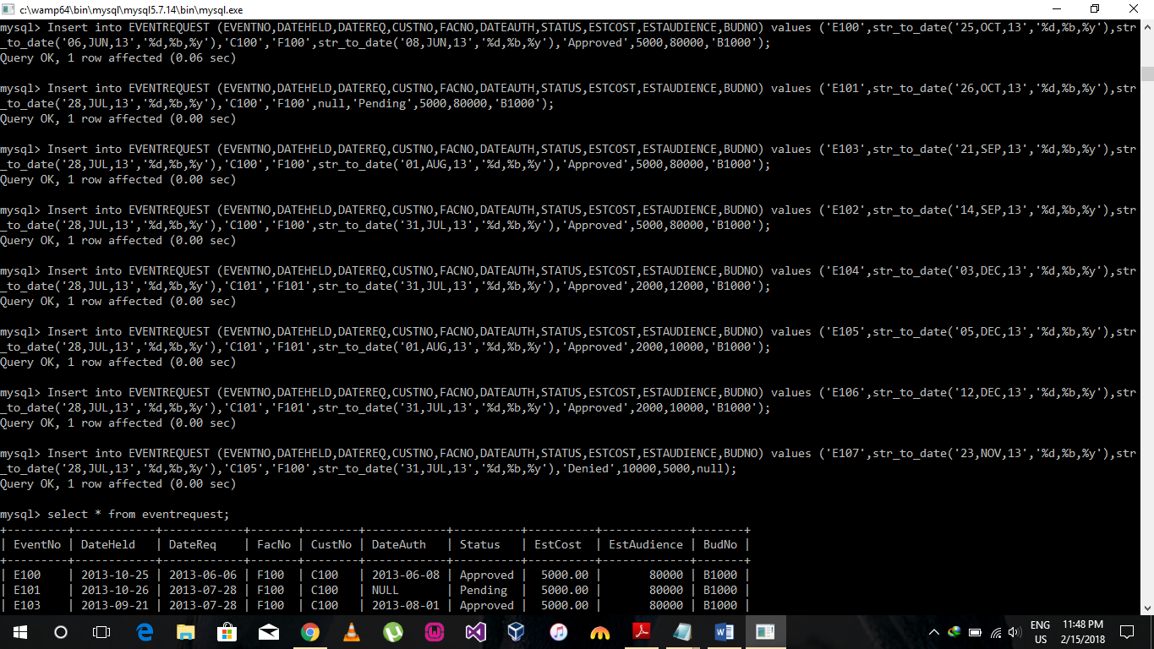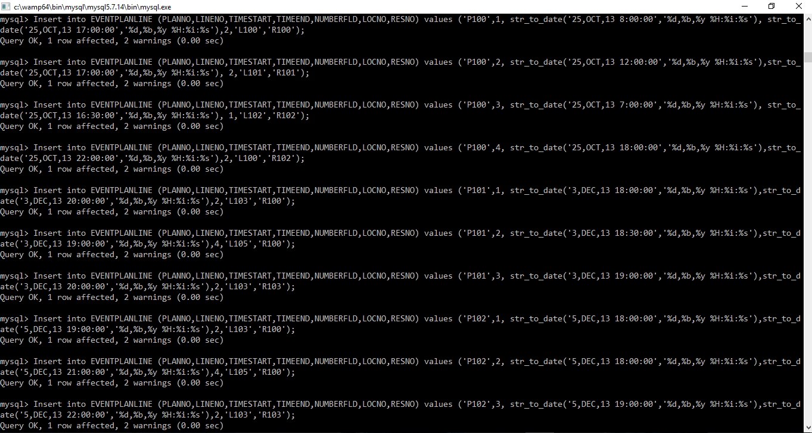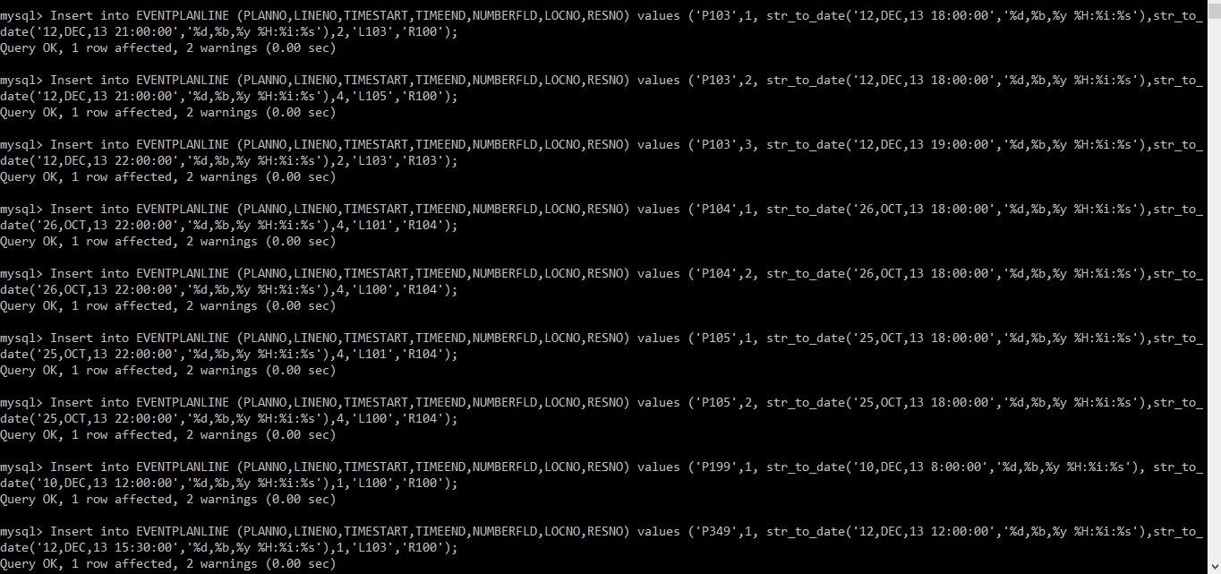

PART(B) A

1. select distinct city, zip, state from customer;

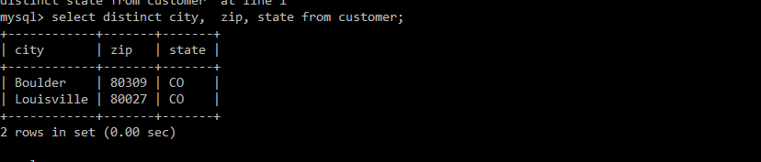

1. select empname,department,phone,email

from employee where phone like '3-%';

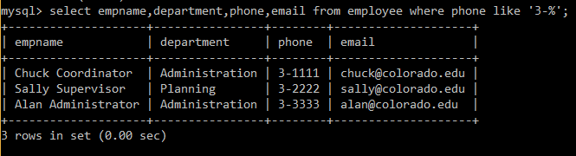

1. select * from resourcetbl where rate between 10 and 20;

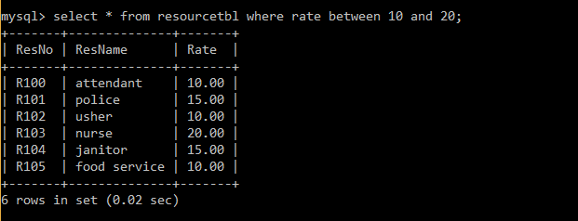

1. select eventno,dateauth,status

from eventrequest

where dateauth like '2013-07%';

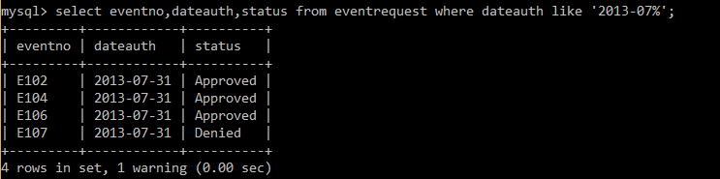

1. select locno,locname

from facility f,location l

where f.facno=l.facno and facname like 'Basket%';

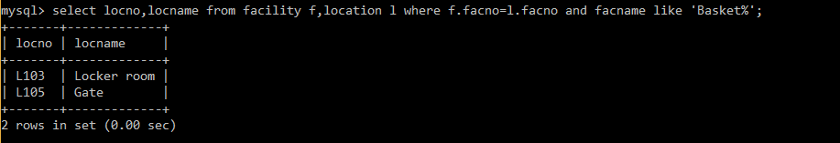

1. select planno,sum(numberfld),count(lineno)

from eventplanline

group by planno;

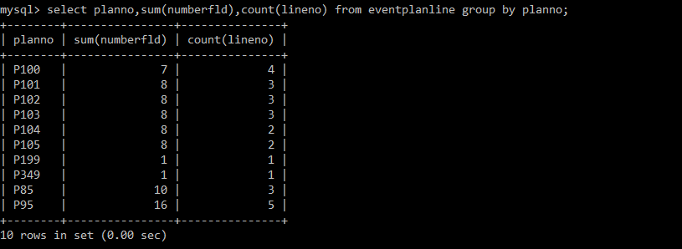

PART(B) B

1. select er.eventno,dateheld,count(planno)

from eventrequest er,eventplan ep

where er.eventno=ep.eventno

and workdate like '2013-12%'

group by planno

having count(planno)>1;



1. SELECT planno,ep.eventno,workdate,activity

FROM eventplan ep,eventrequest er,facility f

where ep.eventno=er.eventno

and f.facno=er.facno

and workdate like '2013-12%'

and facname like 'Basket%';

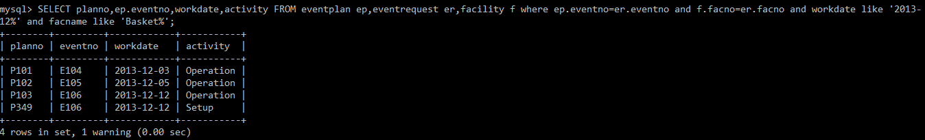

1. select ep.eventno,er.estcost, er.status,ep.workdate

from eventplan ep,eventrequest er,employee e,facility f

where f.facno=er.facno

and e.empno=ep.empno

and ep.eventno=er.eventno

and e.empname='Mary Manager'

and f.facname like 'Basket%'

and dateheld between '01-Oct-2013' and '31-Dec-2013';



1. select epl.PlanNo,LineNo,ResName,NumberFld,LocName,TimeStart,TimeEnd

from EventPlanLine epl,ResourceTbl rt,Location l,EventPlan ep,Facility f

where epl.ResNo = rt.ResNo

and l.LocNo = epl.LocNo

and ep.planno=epl.planno

and f.FacNo = l.FacNo

and FacName like 'Basket%'

and Activity like 'Operat%'

and WorkDate between '01-Oct-2013' and '31-Dec-2013';



PART(B) C

1. INSERT INTO Facility

(FacNo, FacName)

VALUES ('F104', 'Swimming Pool');

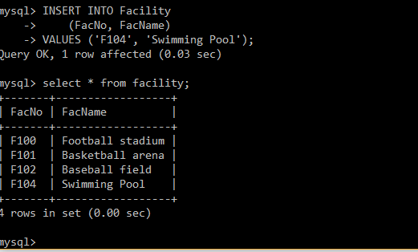

1. INSERT INTO Location

(LocNo, FacNo, LocName)

VALUES ('L107', 'F104', 'Door');

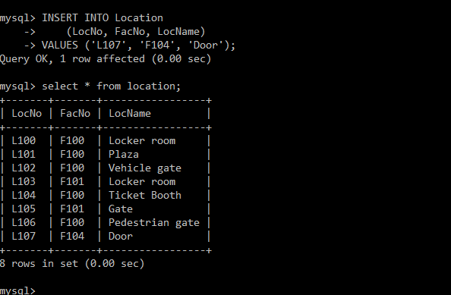

1. INSERT INTO Location

(LocNo, FacNo, LocName)

VALUES ('L108', 'F104', 'Locker Room');

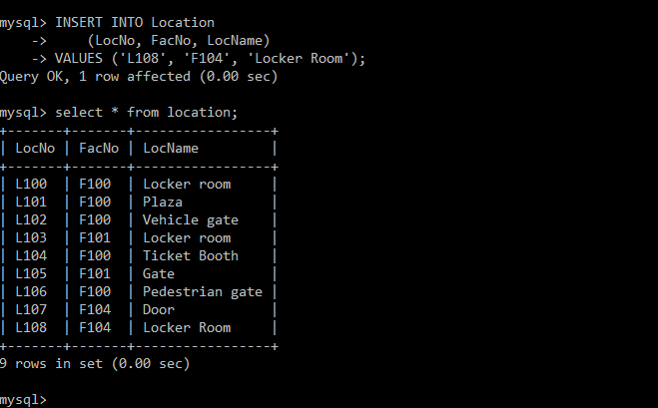

1. UPDATE Location

SET LocName = 'Gate'

WHERE LocNo = 'L107'

AND FacNo = 'F104';

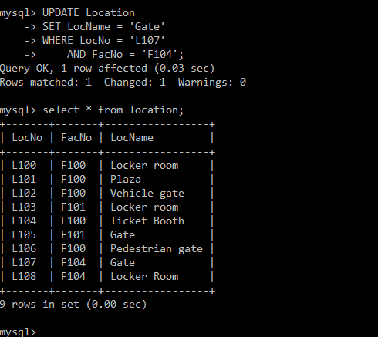

1. delete from location where locno='L107';

